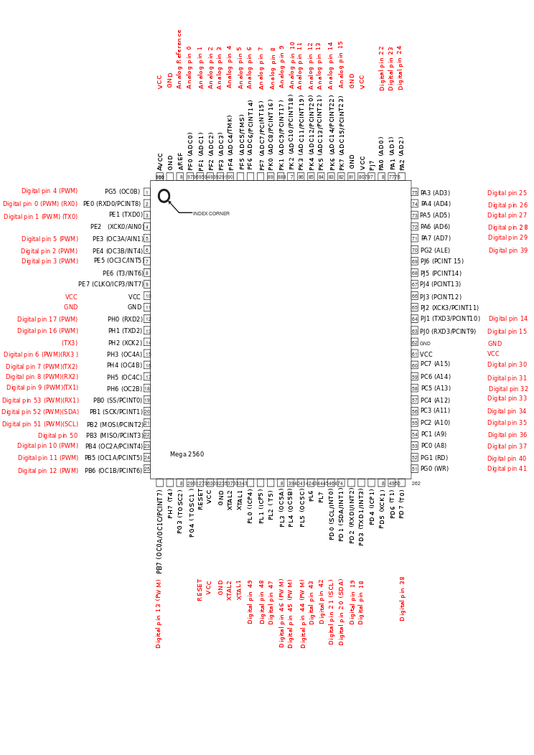Summary
Microcontroller ATmega2560
Operating Voltage 5V
Input Voltage (recommended) 7-12V
Input Voltage (limits) 6-20V
Digital I/O Pins 54 (of which 14 provide PWM output)
Analog Input Pins 16
DC Current per I/O Pin 40 mA
DC Current for 3.3V Pin 50 mA
Flash Memory 256 KB of which 8 KB used by bootloader
SRAM 8 KB
EEPROM 4 KB
Clock Speed 16 MHz

